**Installation and configuration Instructions for Dev-C++**

Download setup application file from Blackboard site.

Run the setup application (Dev-Cpp 5.11 TDM-GCC 4.9.2 Setup.exe).

Select English and click OK

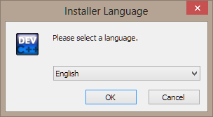

Read and Accept by clicking “I Agree”

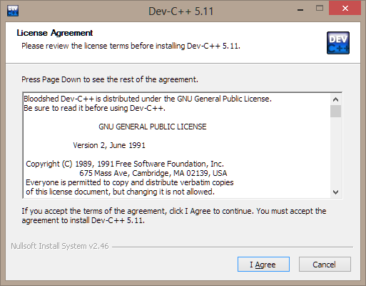

Leave default values selected and click “Next”

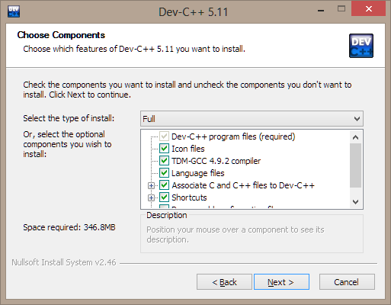

Choose location (or leave default path) and click “Install”

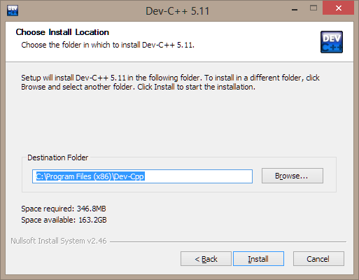

Click “Finish”

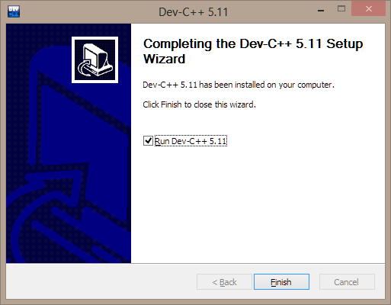

The first time your run Dev C++ you will be asked to configure the environment…

Select “Next” 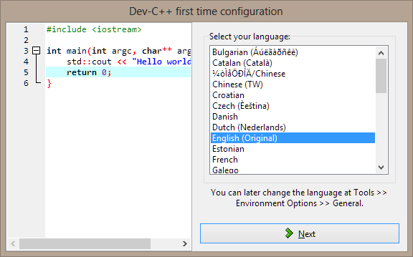

Select “Next” 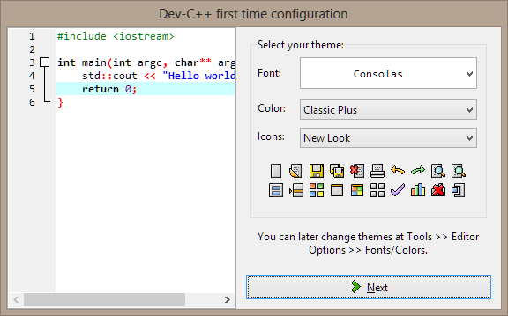

Select “Next” 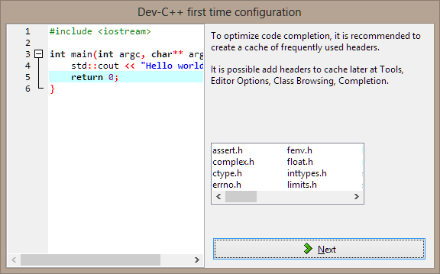

Select “OK” 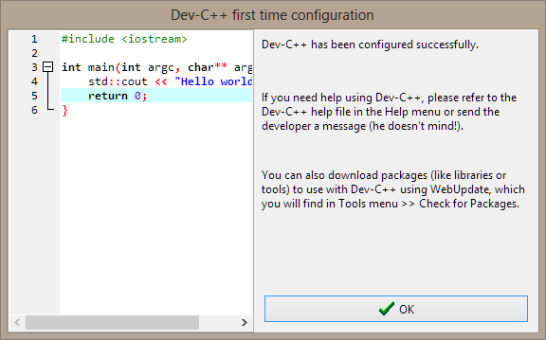

Dev C++ IDE opens and you should get the following window:

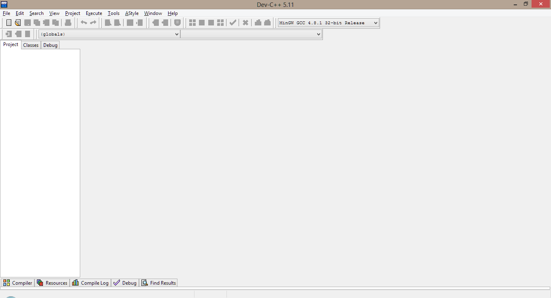

You can now configure the environment options as follows:

Select “Tools” then “Compiler Options”. Select the second tab, “Settings”, then “Code Generation”. Change –std to “ISO C++11”.

